**Q1:**

**a)**

**Y1in= [(-1*1) + (-2*2) + (3*3)] = 4 Y1= AF (4) = 4>0=1**

**Y2in= [(1*1) + (-2*2) + (1.5*3)] =1.5 Y1= AF (1.5) = 1.5>0=1**

**b)**

**Y1in= [(-1*1) + (-2*2) + (3*3)] = 4 Y1= AF (4) = 1/e(-0.5*4)=7.39**

**Y2in= [(1*1) + (-2*2) + (1.5*3)] =1.5 Y1= AF (1.5) =1/e(-0.5*1.5)=2.12**

**Q2:**

1. Ex-OR

|  |  |  |
| --- | --- | --- |
| **X1** | **X2** | **EX_OR** |
| **0** | **0** | **0** |
| **1** | **0** | **1** |
| **0** | **1** | **1** |
| **1** | **1** | **0** |

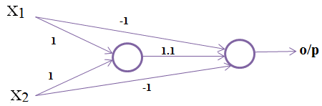

1. EX_NOR

|  |  |  |
| --- | --- | --- |
| **X1** | **X2** | **EX_NOR** |
| **0** | **0** | **1** |
| **1** | **0** | **0** |
| **0** | **1** | **0** |
| **1** | **1** | **1** |

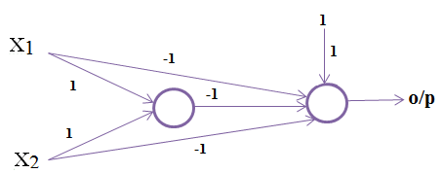

**C)**

